PROBLEM STATEMENT:

Build a Number guessing game, in which the user selects a range. Let’s say user selected a range, i.e., from “lower” to “upper”, where “lower” and “upper” are integers. Some random integer will be selected by the system and the user has to guess that integer in 10 guesses. The system shall display whether the guess is correct or not after each guess. If it’s not correct, the system will display whether to guess a higher number or a lower number. The system also warns the user if they enter a number out of the range. The game stops once the limit is reached.

OUTPUT (PYTHON):

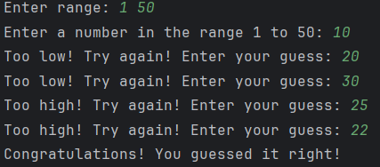

OUTPUT (JAVA):

